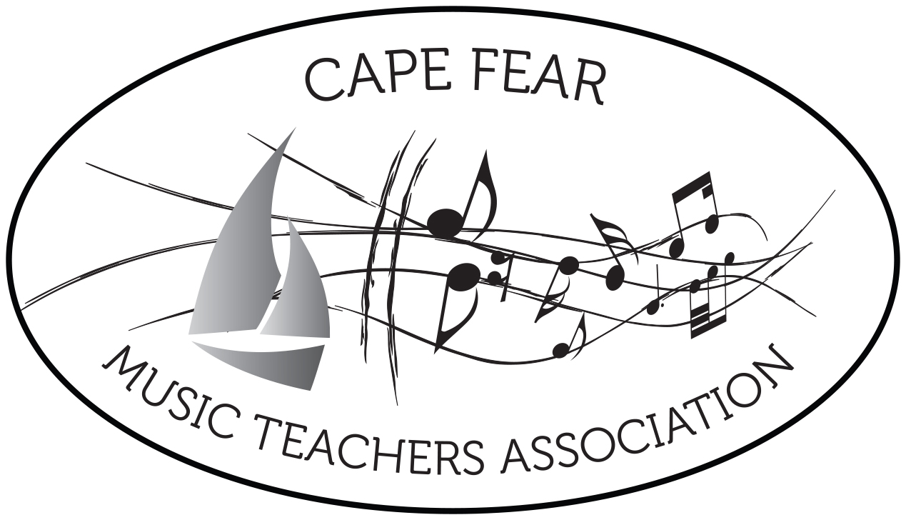

2020
Dear Teachers and Families,

In 2014, Cape Fear Music Teachers Association, affiliated with the North Carolina Music Teachers Association as well as MTNA, adopted a special program called Musician Certification Program (MCP). This program was presented at the NCMTA State Conference in 2013 by the Charlotte Teachers Association. We know that you and your children will benefit greatly as you and they become involved. Here are some details:

OBJECTIVES: To help students observe and explore the world of music and to provide teachers/parents with an educational program that will encourage students to seek a well-rounded music education.

HOW IT WORKS: This program is for all music students who study any instrument or voice. All students who complete the program with sufficient point totals will receive a trophy. Points will be tallied on activities recorded from April 1 through March 31 of the following year. These points will be awarded by your child’s teacher using his/her own point system.

A minimum of 200 points is required per year, with 60 points minimum from each of the three categories: Participation, Observation and Exploration. Points may be recorded in a CFMTA documentation folder, or perhaps on a chart in the studio. In the spring, trophies will be ordered so that, hopefully, each child will receive his/hers by early May.

There will be a registration fee of $20 per student to be collected by each teacher before October 15. This will not only help with the cost of the trophy, but will support the many events such as recitals, master-classes and workshops that are offered by our association each year.

So now, as your child and you attend concerts(virtually, or live!), create compositions, complete lesson books, etc., there will be extra motivation. You will be part of a large wonderful program that many other piano (voice, violin, etc.) students are involved in. There were 132 trophies awarded for our first year!

Thank-you for supporting and encouraging a most well rounded music education for your child as he/she blossoms in this field.

Sincerely,
Mary Paterson, MCP Chairperson

