PARTICIPATION
60 Point Minimum

⧫ School general music class
⧫ School performing organization
⧫ Church music
⧫ Community service performance
⧫ Contests/competitions/recitals
⧫ Performance in any music function
_______________________________________
OBSERVATION
60 Point Minimum

⧫ Recital/Concert (signed program)
⧫ Public Television music concerts
⧫ Musical videos/composer videos
10 facts (no popular videos)
⧫ Attending a music function affiliated
with UNCW, CFCC, WCA, Thalian, etc.
_______________________________________

EXPLORATION
60 Point Minimum

⧫ Music history/composer books
⧫ Independent Study (paper, video, etc.)
⧫ AP or IB music courses
⧫ Composition (minimum 16 ms.)
⧫ Theory test

TOTAL POINTS NEEDED: 200
ENROLLMENT FEE: $15

___________________
The Student

Musician Certification

Program
_______________

Name __________________

Grade__________________

Teacher________________

Registration deadline:

October 15________________
(year)

Deadline to submit this completed
Documentation Folder:

April 1st __________________
(year)

Visit our Website:
http://www.capefearmta.org

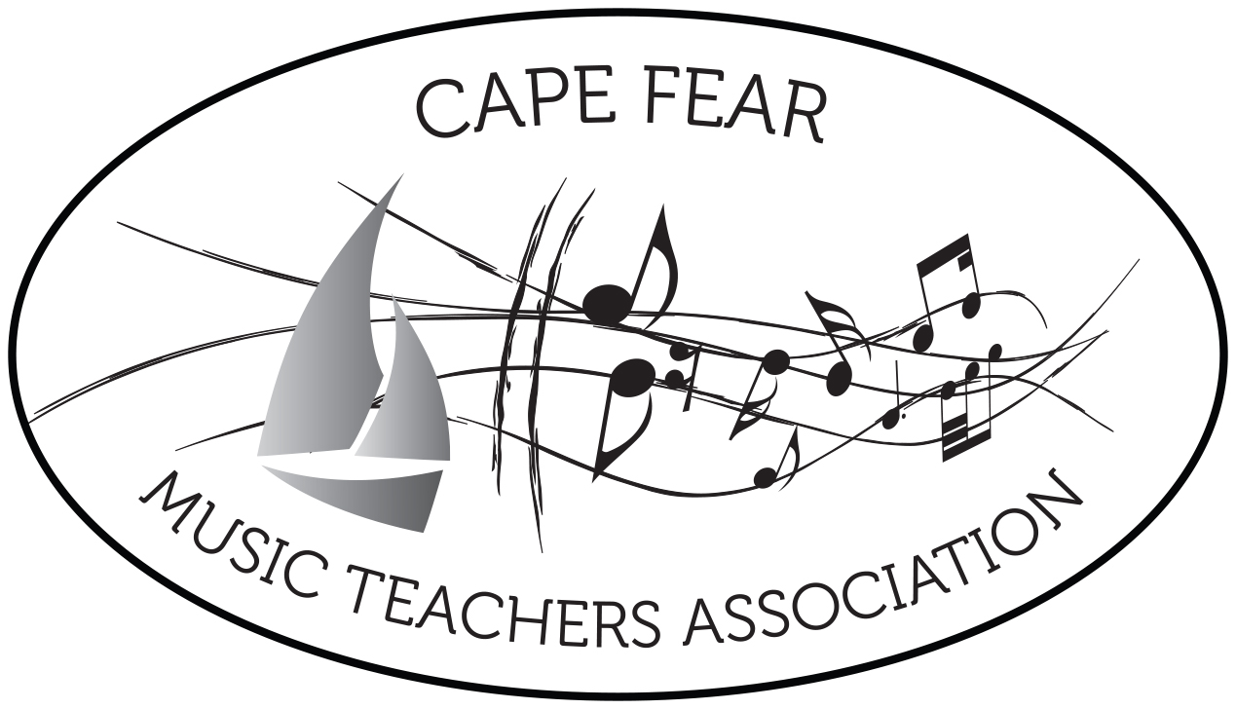

CAPE FEAR MUSIC TEACHERS
ASSOCIATION
proudly sponsors

__________________________

The Student
Musician Certification
Program
______________

Documentation Folder

YEAR: _________

The purpose of this program…

⧫ To motivate students to observe and
explore the world of music

 To provide teachers an educational
program that will encourage students
to seek a well rounded music experience

  

  

